Magnetic Induction 2D Simulator

1. **Introduction**

**1.1 Magnetic Induction**

Each conductor through which an electric current is passed creates magnetic field around it. Magnetic induction is a vector that expresses the magnetic induction in a point in space. The symbol for magnetic induction is $\vec{B}$.

A conductor that has an electric current with an intensity I creates an infinite number of concentric circles that are centred on itself. The magnetic induction vector for a point in space is tangent to the circle that passes through the point. The direction of the magnetic induction is found using the right-hand rule.

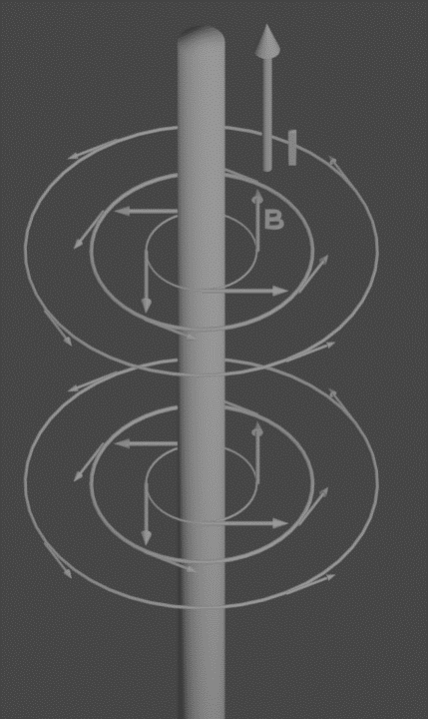

Fig. 1

In order to define the value of $\vec{B}$ we will start from the action of electromagnetic force created against a conductor that has electric current passing through it.

Electromagnetic force is defined as being the force created by the magnetic field against a conductor that conducts electrical current and that is positioned in that magnetic field. The direction of the electromagnetic force vector is determined with the left-hand rule.

Experimentally, it was found that electromagnetic force $\vec{F}$ is directly proportional with the intensity of the current through the conductor I. It was also found that the force is directly proportional to the length of the conductor. Because of this, the force is directly proportional to the length of the conductor multiplied by the intensity of the current through the conductor.

$\vec{F} \sim I, \vec{F} \sim l→\vec{F} \sim I∙l$

*

By dividing both sides by $I∙l$, the following relationship occurs:

$$\frac{\vec{F}}{I∙l}\sim const$$

From this it results that the electromagnetic force divided by the intensity of current multiplied by the length of the conductor is a constant. From this we will define the formula for magnetic induction.

$$B=\frac{F}{I∙l} \left(1\right)$$

Formula (1) is the definition for the modulus of the magnetic induction.

The unit of measurement for magnetic induction is:

$$\left[B\right]=\frac{\left[F\right]}{\left[I\right]\left[l\right]}=\frac{N}{A∙M}=T\left(Tesla\right)$$

The unit was named Tesla after the great physicist Nikola Tesla.

* 1. **Magnetic Induction Formula**

As it was shown before, the general formula for magnetic induction has been defined, but this is only in the general case, however using it in practice would be difficult. Because of this, we will now derive another simple formula for when the conductor is straight.

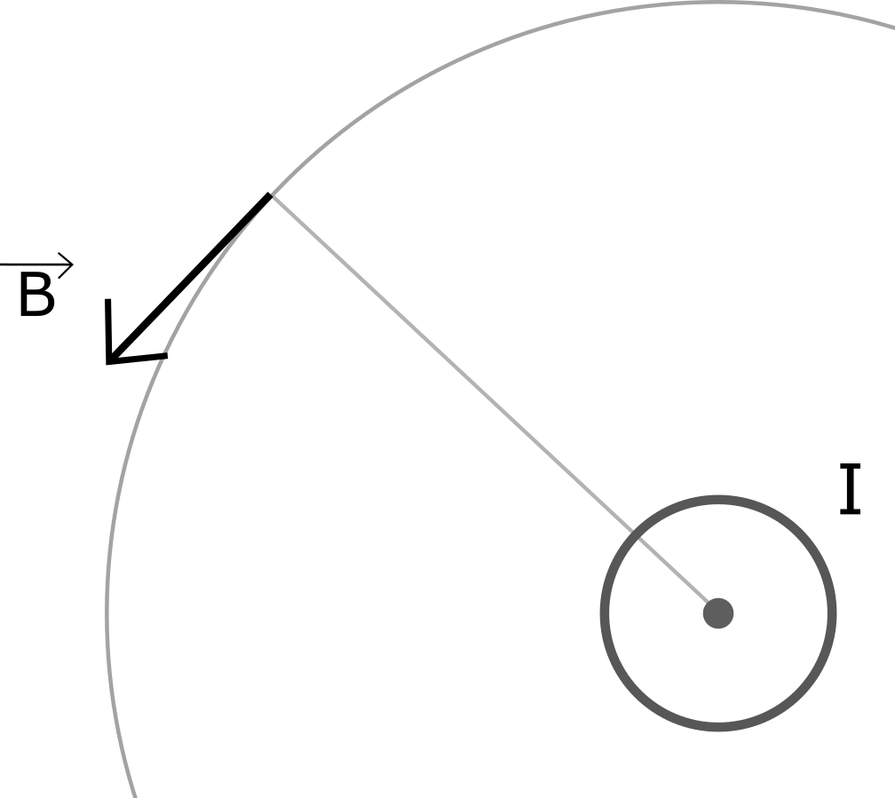

Fig. 2

The following proprieties were experimentally observed:

The magnetic induction is directly proportional to the intensity of the current through the conductor, and inversely proportional to the distance between the point and the conductor:

$$B \sim I, B \sim \frac{1}{r}→B \sim \frac{I}{r}$$

This relationship shows that the magnetic induction is proportional to the current and inversely proportional to the distance. A new constant will be introduced, called the permeability of space, written as *μ*. The permeability of vacuum has the following value:

$$μ_{0}=4π∙{10}^{-7}\frac{N}{Am}$$

And we will add another term into the final formula, called the relative permeability of space, noted with *μr*. This is a constant per material and is dimensionless, meaning it has no unit of measurement. The relative permeability shows the permeability of the material relative to the permeability of vacuum. Here are the values of *μr* for a few materials:

|  |  |
| --- | --- |
| Material | Maximum relative permeability |
| Metglas 2714A | 1000000 |
| 99.95% Iron annealed in Hydrogen | 200000 |
| Permalloy | 100000 |
| Mu-metal | 20000 |
| Cobalt-iron | 18000 |
| Ferrite (Manganese zinc) | 350-20000 |
| Carbon steel | 100 |
| Nickel | 100-600 |
| Platinum | 1.0002 |
| Water | 0.9999 |
| Superconductors | 0 |

The final formula is going to become:

$$B=μ_{0}μ_{r}\frac{I}{2πr} \left(2\right)$$

There are also formulas for a loop of wire and bobbins. It is out of the scope of this document to also derive the other ones.

* 1. **Decomposition of Magnetic Induction into X and Y Components**

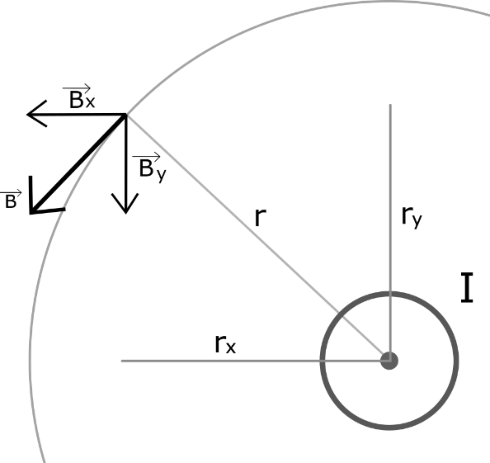

Fig. 3

Looking at Fig. 3, the magnetic induction vector $\vec{B}$ is placed at a point in space, being tangent to the circle passing through the point and that is centred on the conductor.

The magnetic induction vector can be decomposed as components in the x and y axis, being $\vec{B_{x}}$ and $\vec{B_{y}}$ respectively, such that the relationship $\vec{B}=\vec{B_{x}}+\vec{B_{y}}$ takes place:

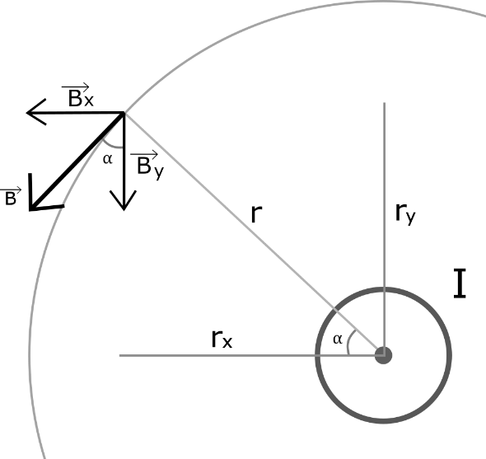

Fig.4

It was added to Fig. 4 that the angle α created between the x and y components of $\vec{B}$ is the same angle as created between the distances rx and ry. Because of this, we can use the trigonometry to calculate the x and y components of the magnetic induction vector.

Using trigonometry, the following relationships occur:

$$\sin{α}=\frac{B_{x}}{B}\left(3.1\right), \cos{α}=\frac{B_{y}}{B} \left(3.2\right)$$

We can now calculate the components using:

$$B_{x}=B∙\sin{α}\left(3.1.1\right), B_{y}=B∙\cos{α} \left(3.2.1\right)$$

In the triangle created by r, rx and ry, the angle α can be calculated using:

$$α=\tan^{-1}{\frac{r_{y}}{r_{x}}}\left(3.3\right)$$

In pure mathematics, the result will be:

$$α:\left\{\tan^{-1}{\frac{r_{y}}{r_{x}}}+kπ | k∈Z\right\}$$

However, we will only consider α of the above formula where k = 0.

Because of (3.2.1) and (3.3), the formula for the components now becomes:

$$B_{x}=B∙\sin\left(\tan^{-1}{\frac{r_{y}}{r_{x}}}\right) \left(3.4.1\right)$$

$$B_{y}=B∙\cos\left(\tan^{-1}{\frac{r_{y}}{r_{x}}}\right) \left(3.4.2\right)$$

And, with (3.4.1) and (3.4.2), the following relationship must be true:

$$B^{2}=B_{x}^{2}+B_{y}^{2} \left(3.5\right)$$

It is possible now to create a vector field that attributes each point in space a magnetic induction vectors in the x and y directions.

1. **How the Program Works**

Now that the necessary physics needed to create the program has been introduced, we will continue with a short explanation on how the program works.

The program, written in C, works by creating a tensor (meaning a 3D matrix) of structures in order to simulate a vector field. Each structure contains the x and y positions of the point, the x and y components of the magnetic induction vector, and the modulus of the magnetic induction vectors. The program iterates through each magnetic point in order to calculate the modulus and x and y components of the magnetic induction with the formulas shown above.

After this process, a vector field is created. However, multiple conductors can be added into the simulation. This is done by calculating all of the vectors in the vectors field and creating a separate tensor of structures; this being just a repetition of the first part. Finally, in order to calculate the final result the program adds the x and y components of $\vec{B}$ that are on the same coordinates in the simulation and calculates the modulus of the magnetic induction vector using formula (3.5).

The addition of the individual components is derived from the general formula of vector addition, knowing that there is a 0 degree angle between them:

$$B_{x}^{2}=B_{x_{1}}^{2}+B_{x_{2}}^{2}+2B_{x_{1}}^{2}B_{x_{2}}^{2}\cos{0}$$

$${⇒B}_{x}^{2}=B_{x_{1}}^{2}+2B_{x_{1}}^{2}B_{x_{2}}^{2}+B_{x_{2}}^{2}$$

Here the right-hand part of the equation is a binomial

$${⇒B}_{x}^{2}=\left.{\left(B_{x_{1}}+B_{x_{2}}\right)}^{2}\right|\sqrt{\left(∙\right)}$$

$$B_{x}=B_{x_{1}}+B_{x_{2}} \left(3.6.1\right)$$

The same principle is used for the y component:

$$B_{y}=B_{y_{1}}+B_{y_{2}} \left(3.6.2\right)$$

The resulting vector field is finally written to a file.